CloudTrail with Athena integration for log analyzing

1.What is Cloud Trails ? configure a S3 bucket for cloudtrails.
- Cloud trail is an aws service used to store activity logs and api call history .
- The retention period of logs is 90 days
- We can configure cloud trails to store the logs permanently using S3 bucket.
- To efficiently use/handle millions and billions of logs , we can integreate Athena analytics service to analysis the logs .
- Reference - itmukesh-16/Athena
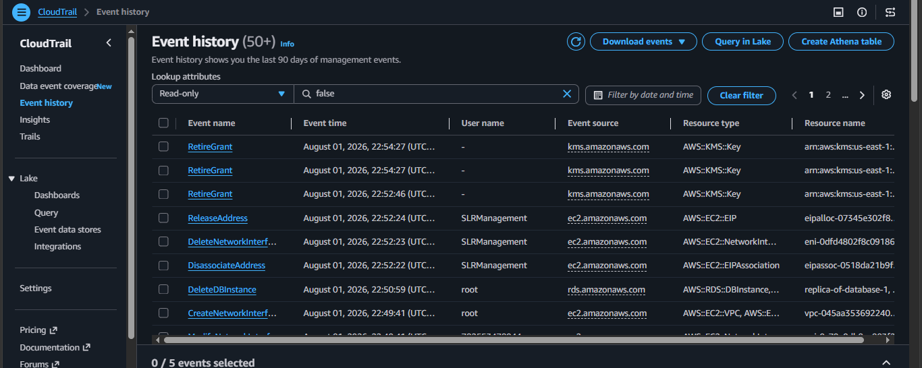

Store CloudTrail data into S3 bucket also integrate Athena to analyze the logs .
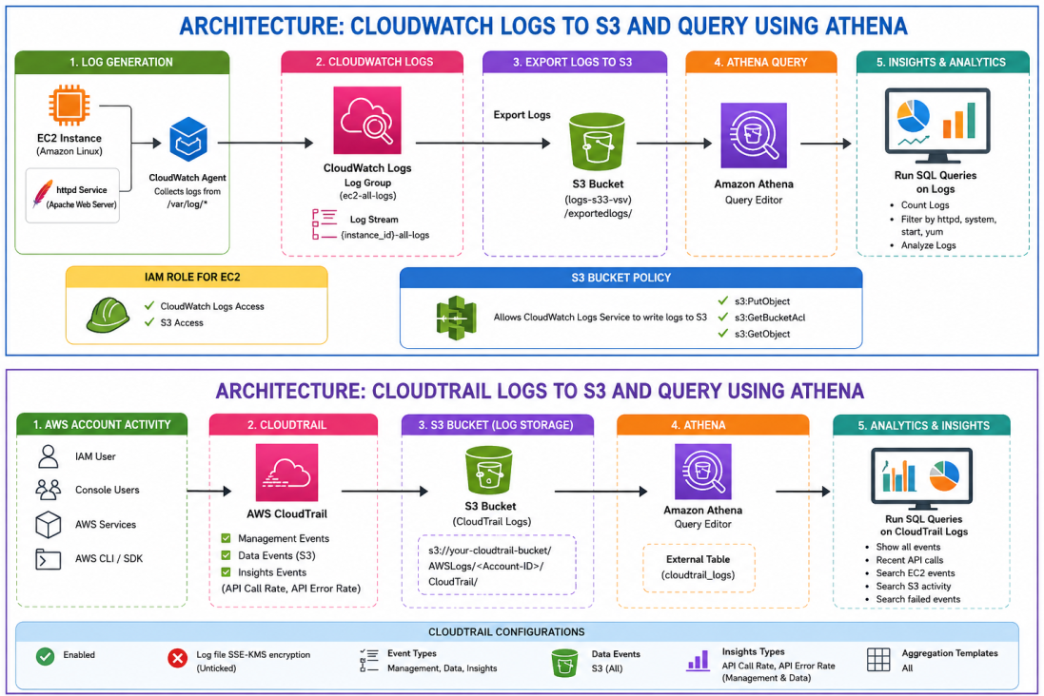

Open Cloud Trails > trails >Create trails.
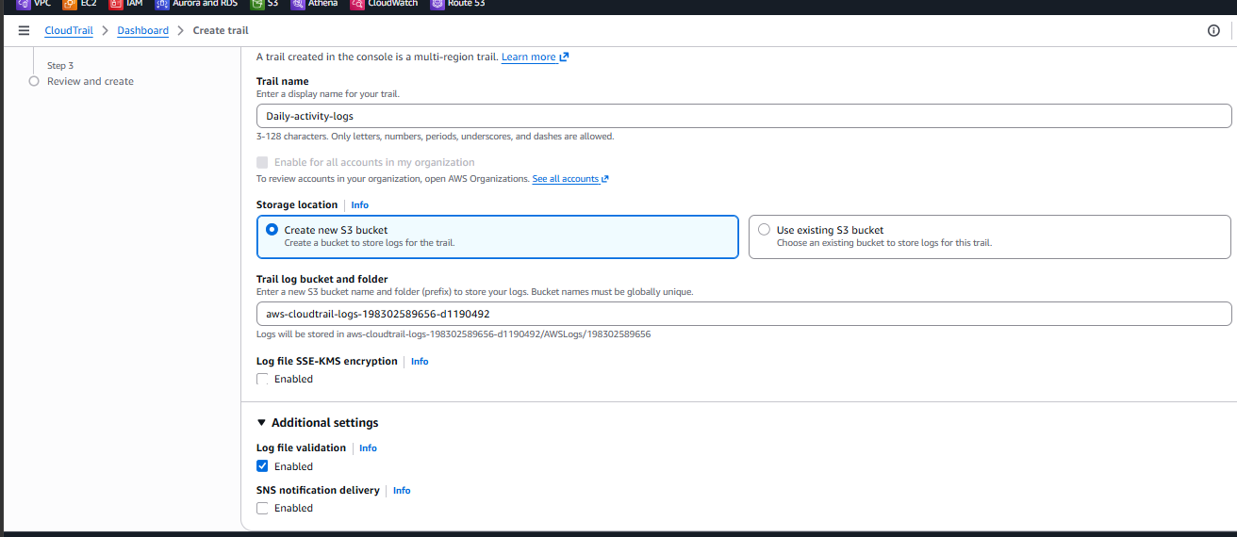
Select all required options
Now go to S3 bucket to check if the log bucket created or not
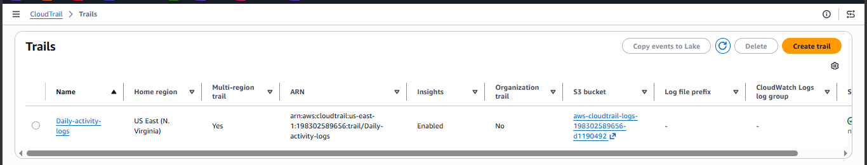
We can see the logs stored into S3 bucket.
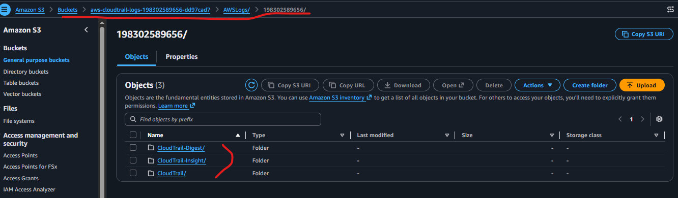

Now integrate Athena for analyzing logs (Athena doesn’t store data it only fetch data from source and analyze the data ,it only charges per query cost . it has max duration of 15min)
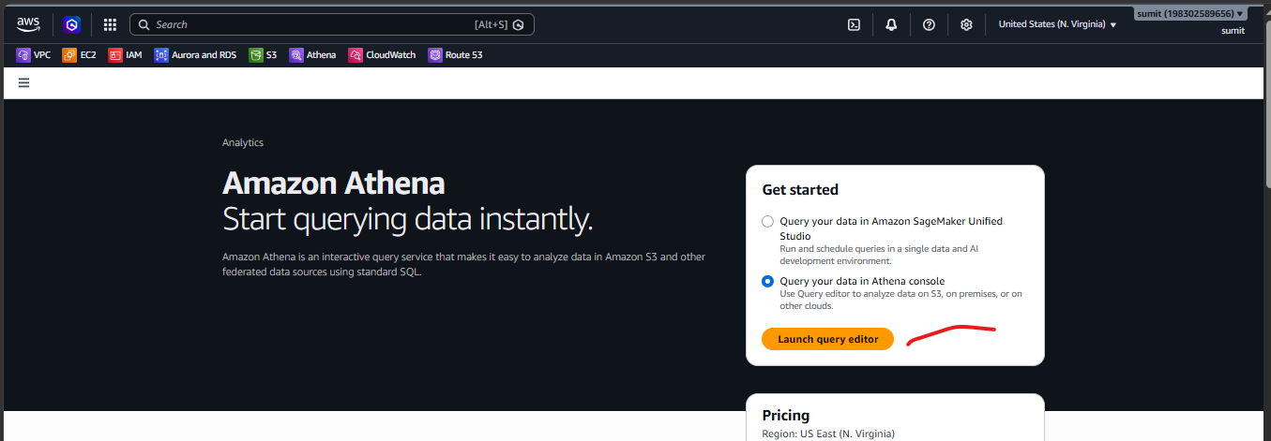

Choose query settings tab > manage > give bucket name
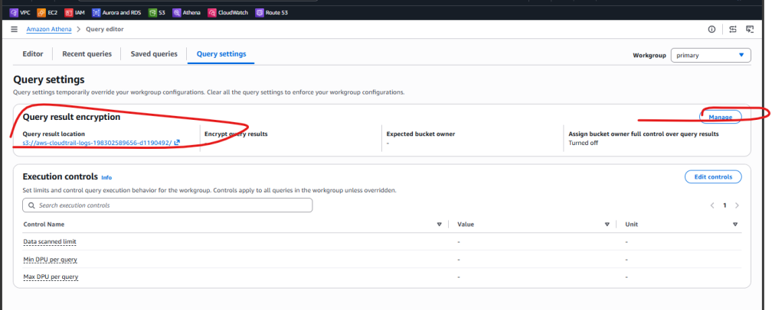

Go to Editor >create a database (it doesn’t store any actual data, its just reference for logs)
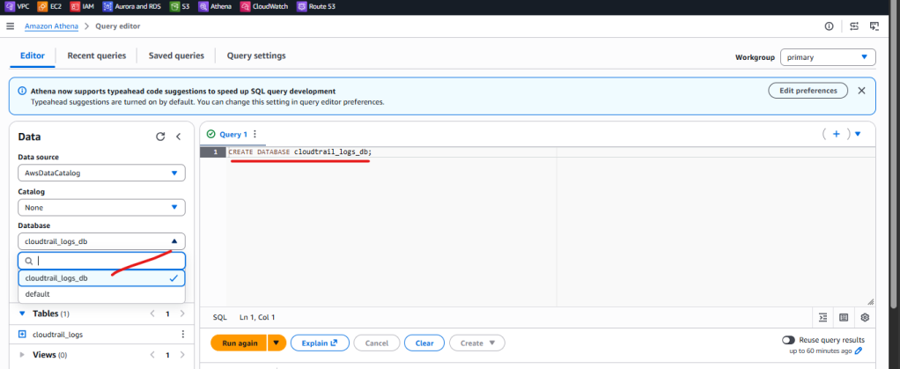

Create a schema , its basically log structure ,ie tells how data stored in s3 bucket (column names , rows,foreign keys etc).open a new tab and run the query . make sure you are giving s3 bucket name and account id
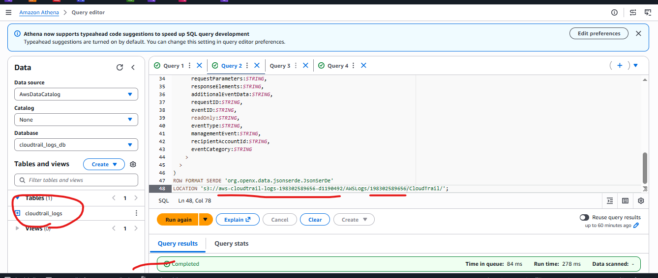
Now open new query tab and run a sql query to fetch the log data of a particular date
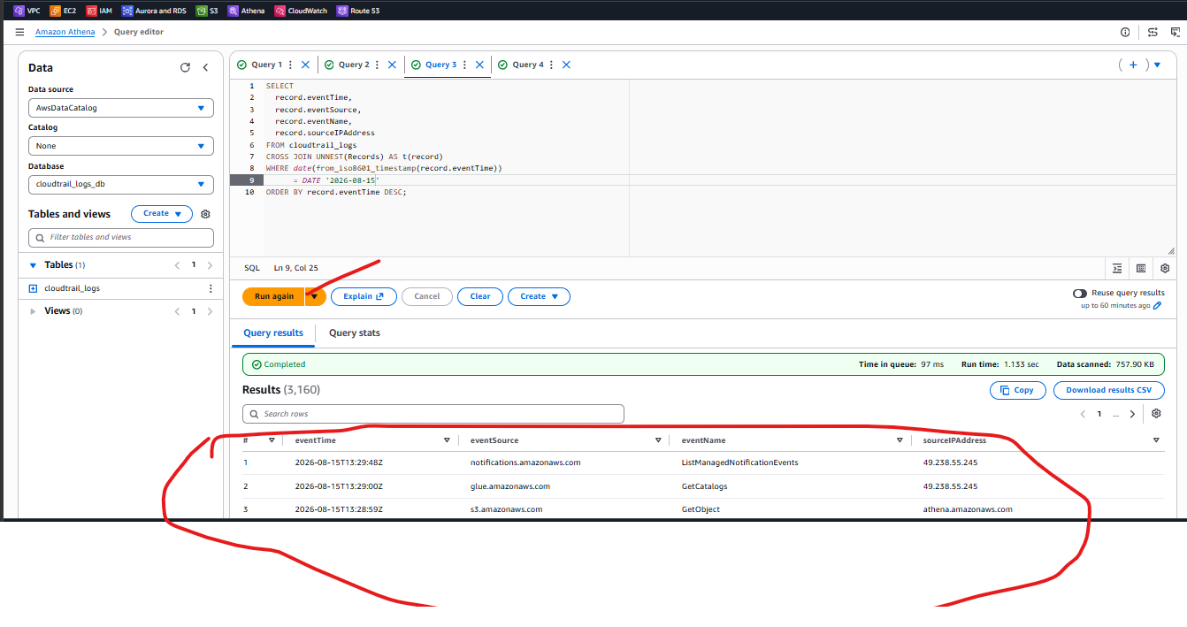
Task Over

